**Hotel booking for attending**

**17th International Hydrogen & Energy Symposium**

The symposium will be held in ***Days Hotel by WYNDHAM* （戴斯温德姆酒店）**located at No. 2 Honghu St., Daoli Dist., Harbin, China. You can check the hotel’s information via <https://hotels.ctrip.com/hotels/detail/?hotelId=115644681>.

There is also a hotel named ***DaysInn Hotel by WYNDHAM*** **（戴斯精选温德姆酒店）**very nearby *Days Hotel by WYNDHAM.*The guests in the *DaysInn Hotel* have breakfast in the *Days Hotel* by walking outside for 1~2 minutes.

Two hotels could be booked in advance by filling the following form and sending the form to [zhangjinqiu@hit.edu.cn](mailto:zhangjinqiu@hit.edu.cn) before Feb. 1st, 2025.

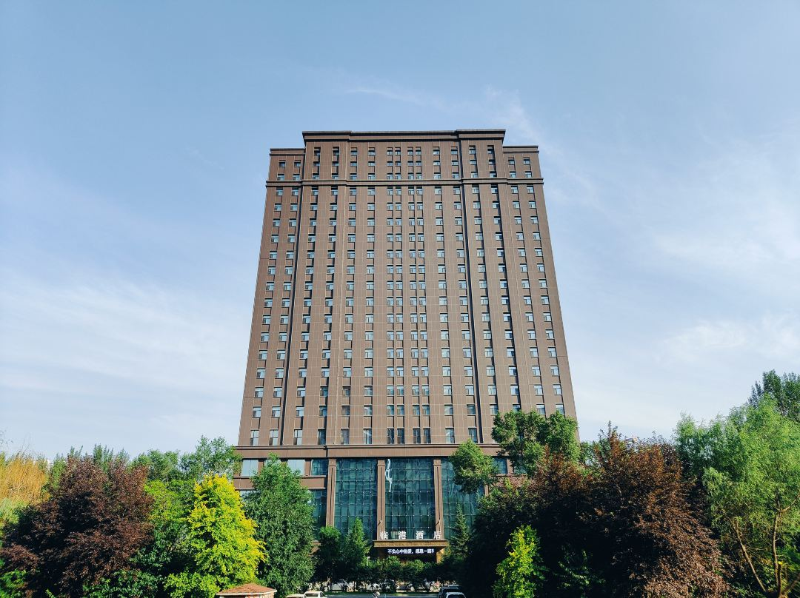 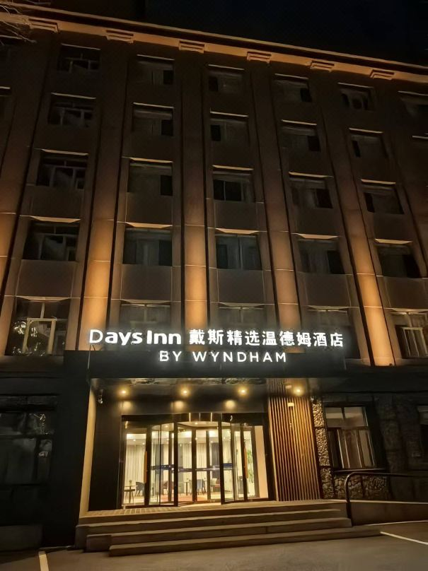

***Days Hotel by WYNDHAM DaysInn Hotel by WYNDHAM***

**Guests’ Name: (1)**  **(2) Tel:**

**Arrival Date： Departure Date：**

|  |  |  |  |  |  |
| --- | --- | --- | --- | --- | --- |
| **Hotel** | **Room** | **Feb. 15** | **Feb. 16** | **Feb. 17** | **Total** |
| ***Days***  ***Hotel by WYNDHAM***  **戴斯**  **温德姆酒店** | King size bed room with one bed  大床房 | CNY 550  Book □  Not Book □ | CNY 350  Book □  Not Book □ | CNY 350  Book □  Not Book □ | 1 Night □  2 Nights □  3 Nights □ |
| Queen size bed room with two beds  双床房 | CNY 550  Book □  Not Book □ | CNY 350  Book □  Not Book □ | CNY 350  Book □  Not Book □ | 1 Night □  2 Nights □  3 Nights □ |
| Family room with two beds  家庭房 | CNY 600  Book □  Not Book □ | CNY 400  Book □  Not Book □ | CNY 400  Book □  Not Book □ | 1 Night □  2 Nights □  3 Nights □ |
| Suit room with one bed  套房 | CNY 700  Book □  Not Book □ | CNY 500  Book □  Not Book □ | CNY 500  Book □  Not Book □ | 1 Night □  2 Nights □  3 Nights □ |
| ***DaysInn Hotel by WYNDHAM***  **戴斯精选**  **温德姆酒店** | King size bed room with one bed  大床房 | CNY 450  Book □  Not Book □ | CNY 300  Book □  Not Book □ | CNY 300  Book □  Not Book □ | 1 Night □  2 Nights □  3 Nights □ |
| Queen size bed room with two beds  双床房 | CNY 450  Book □  Not Book □ | CNY 300  Book □  Not Book □ | CNY 300  Book □  Not Book □ | 1 Night □  2 Nights □  3 Nights □ |
| Family room with two beds  家庭房 | CNY 500  Book □  Not Book □ | CNY 350  Book □  Not Book □ | CNY 350  Book □  Not Book □ | 1 Night □  2 Nights □  3 Nights □ |